Project name: Unit 4: For a better community | Screen title: Introduction | Screen #: 1/12
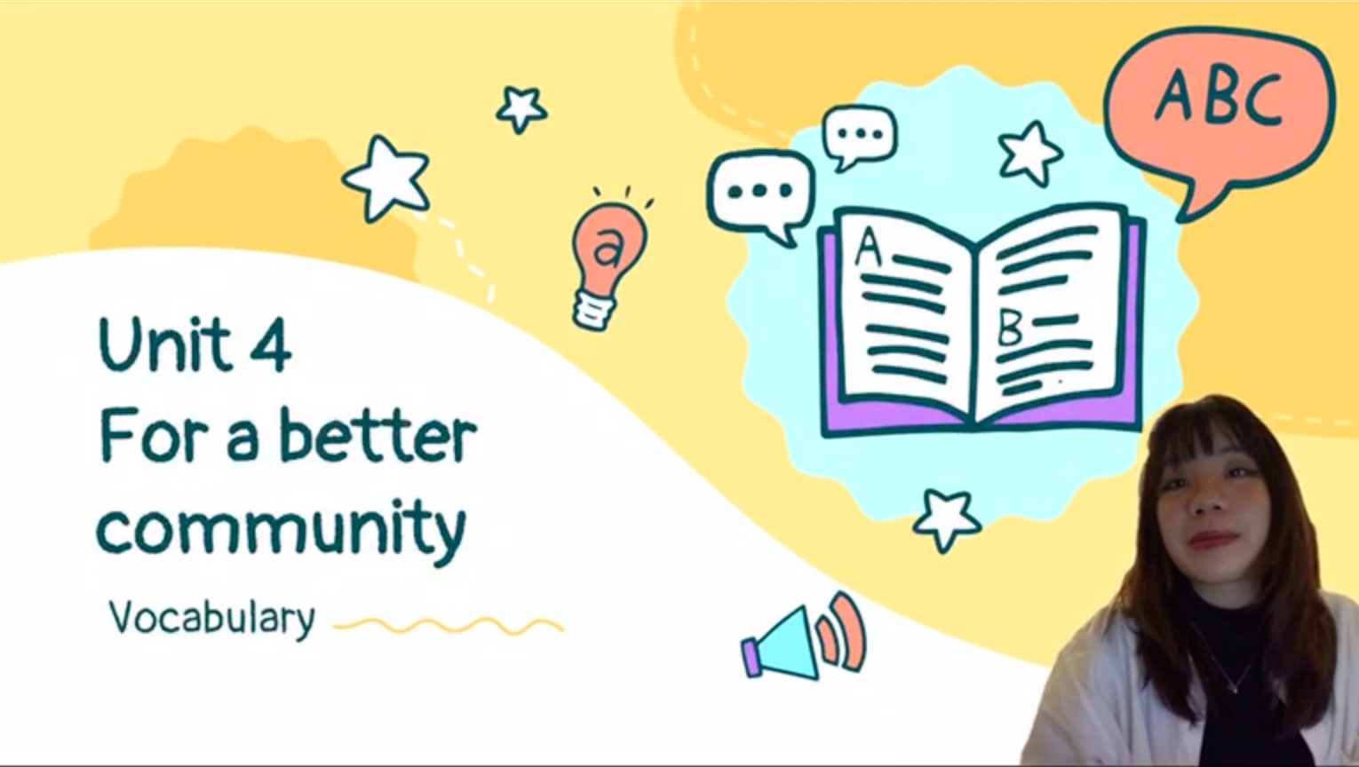 |  | Graphic info:
 |  | [None]
 |  | Navigation:
Animation
[1] Unit 4: For a better community
[2] Vocabulary
 |  | Reviewer comments:
Audio
Hello everyone, welcome back to my class, today we’re going to learn some vocabulary in unit 4: For a better community.

Project name: Unit 4: For a better community | Screen title: First word | Screen #: 2/12
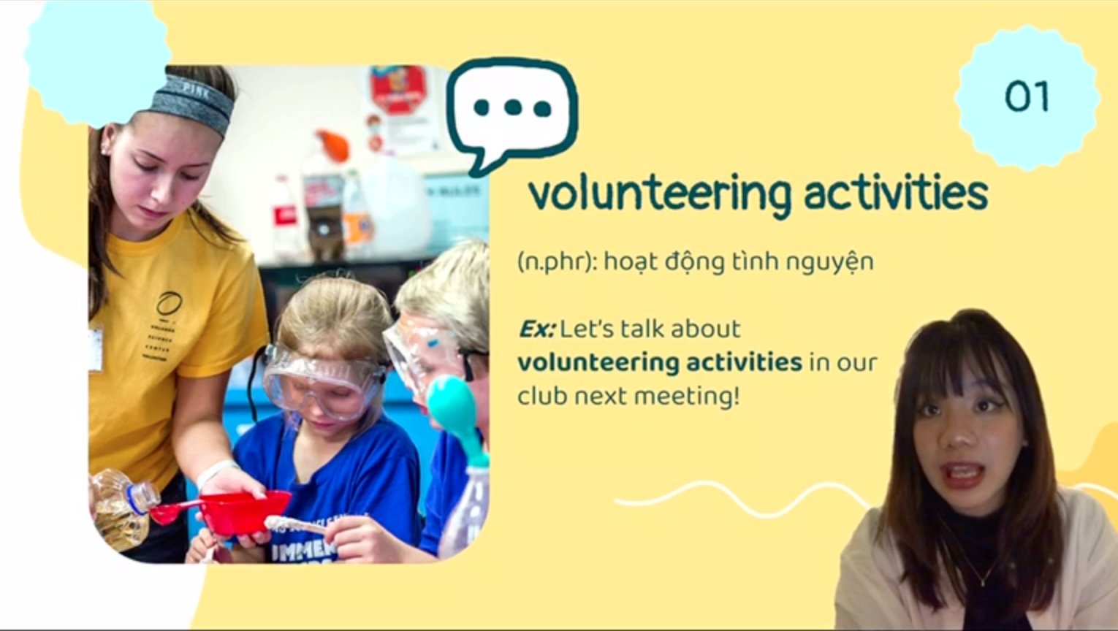 |  | Graphic info:
 |  | [A girl helping children]
 |  | Navigation:
Animation
[1] graphic
[2] volunteering activities
[3] (n.phr): hoạt động tình nguyện
[1] Ex: Let’s talk about volunteering activities in our club next meeting!

 |  | Reviewer comments:
Audio
Let’s move to the first word, this is something you do to help less fortunate people and our community and we do it for free! That is: “volunteering activities”. We can use it in a sentence as: “Let’s talk about volunteering activities in our club next meeting!”

Project name: Unit 4: For a better community | Screen title: 2nd word | Screen #: 3/12
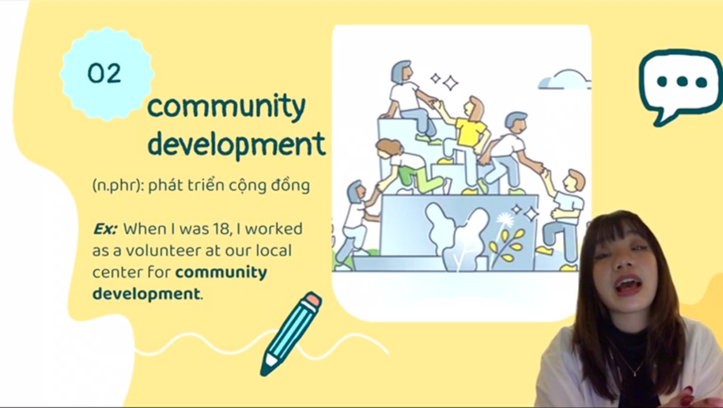 |  | Graphic info:
 |  | [People helping each other]
 |  | Navigation:
Animation
[1] graphic
[2] Community development
[3] n.phr: phát triển cộng đồng
[4] Ex: When I was 18, I worked as a volunteer at our local center for community development.
 |  | Reviewer comments:
Audio
The next word is a noun, it indicates the state of people around us getting better. The word is “community development”. We can use it in a sentece as: “When I was 18, I worked as a volunteer at our local center for community development.”

Project name: Unit 4: For a better community | Screen title: 4th word | Screen #: 4/12
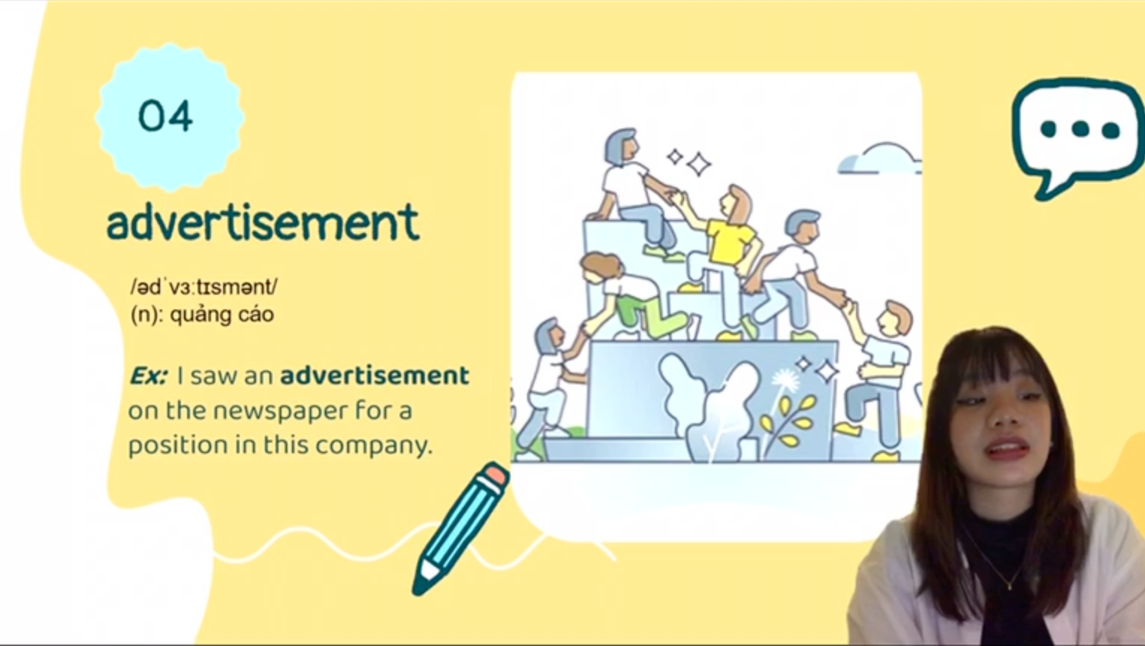 |  | Graphic info:
 |  | [People helping each other]
 |  | Navigation:
[1] graphic
[2] advertisement
[3](n): quảng cáo
[4]: Ex: I saw an advertisement for a position in this company
 |  | Reviewer comments:
Audio
Imagine you have a company and you want everyone to know about your product, what would you do? Yes, we would use advertisement.We can use it in a sentence as “I saw an advertisement for a position in this company”

4. Project name: Unit 4: For a better community | Screen title: 5th word | Screen #: 5/12
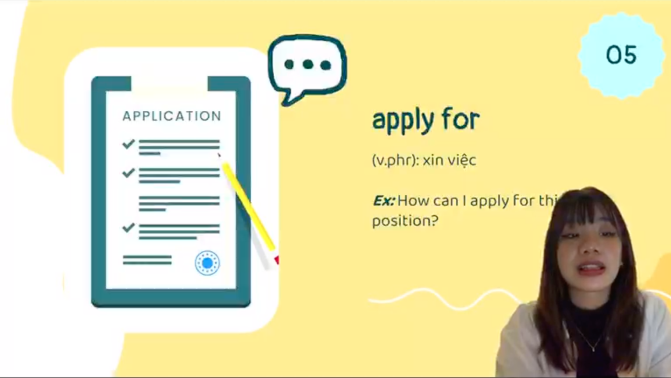 |  | Graphic info:
 |  | [Application form]
 |  | Navigation:
Animation
[1] graphic
[2] apply for
[3] v.phr: xin việc
[4]: Ex: How can I apply for this position?
 |  | Reviewer comments:
Audio
If we see a company needing employees, and we need a job, what would we do? Yes, we would “apply for that position” in the company.

Project name: Unit 4: For a better community | Screen title: 6th word | Screen #: 6/12
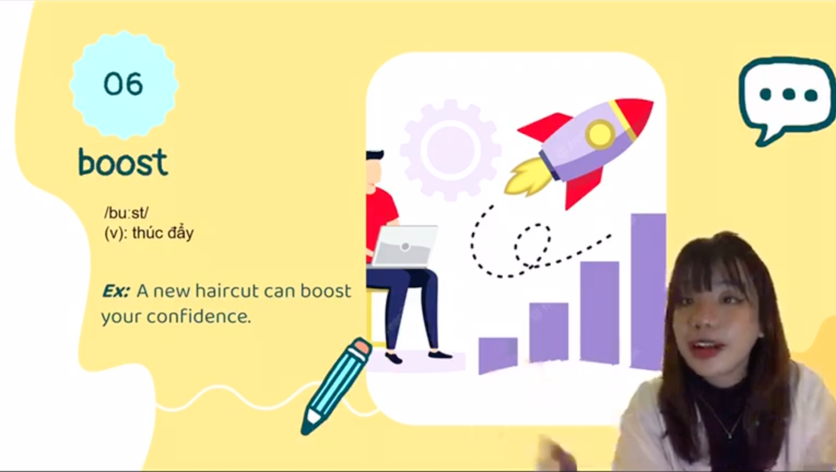 |  | Graphic info:
 |  | [Man working while things elevate]
 |  | Navigation:
Animation
[1]: graphic
[2]: boost
[3] (v): thúc đấy
[4] Ex: A new haircut can boost your confidence.
 |  | Reviewer comments:
Audio
So when you are feeling really sad, and your favorite TV show lifts up your mood, we can say it “boosted” your mood. The word “boost” can be used in the sentence as “a new haircut can boost your confidence”.

Project name: Unit 4: For a better community | Screen title: 7th word | Screen #: 7/12
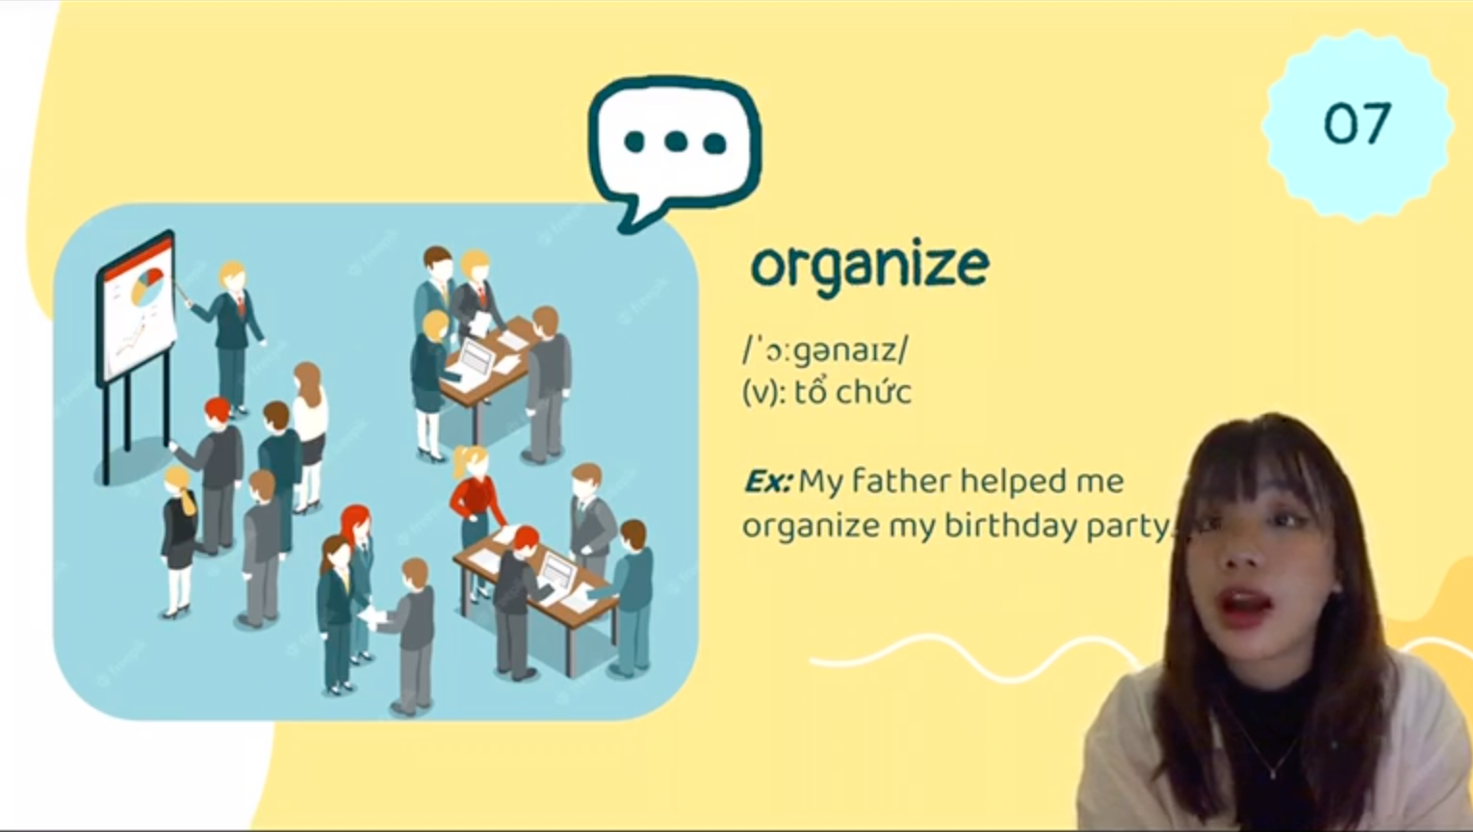 |  | Graphic info:
 |  | [People working together]
 |  | Navigation:
Animation
[1] graphic
[2] organize
[3] (v): tổ chức
[4]: Ex: My father helped me organize my birthday party
 |  | Reviewer comments:
Audio
Move on to the next word, when people have to schedule, plan or brainstorm for an event or a project to happen, we can say they “organize” them. It can be said “My father helped me organize my birthday party”

Project name: Unit 4: For a better community | Screen title: 8th word | Screen #: 8/12
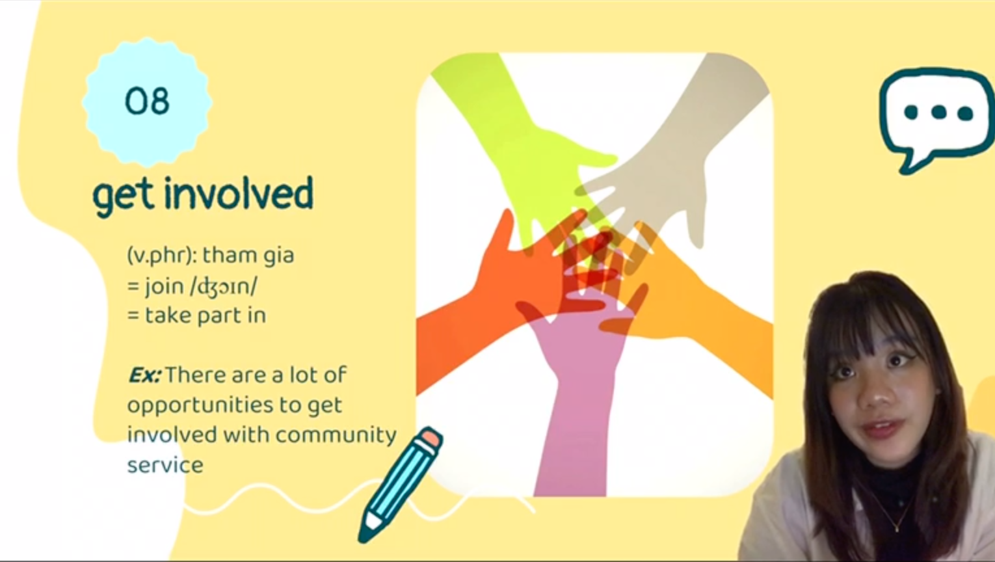 |  | Graphic info:
 |  | [joined hands]
 |  | Navigation:
Animation
[1] graphic
[2] get involved
[3]: (v.phr): tham gia
[4]: Ex: There are a lot of opportunities to get involved with community service.

 |  | Reviewer comments:
Audio
This word is a verb, when you want to join something, you can say I want to “get involved” in it.

Project name: Unit 4: For a better community | Screen title: 9th word | Screen #: 9/12
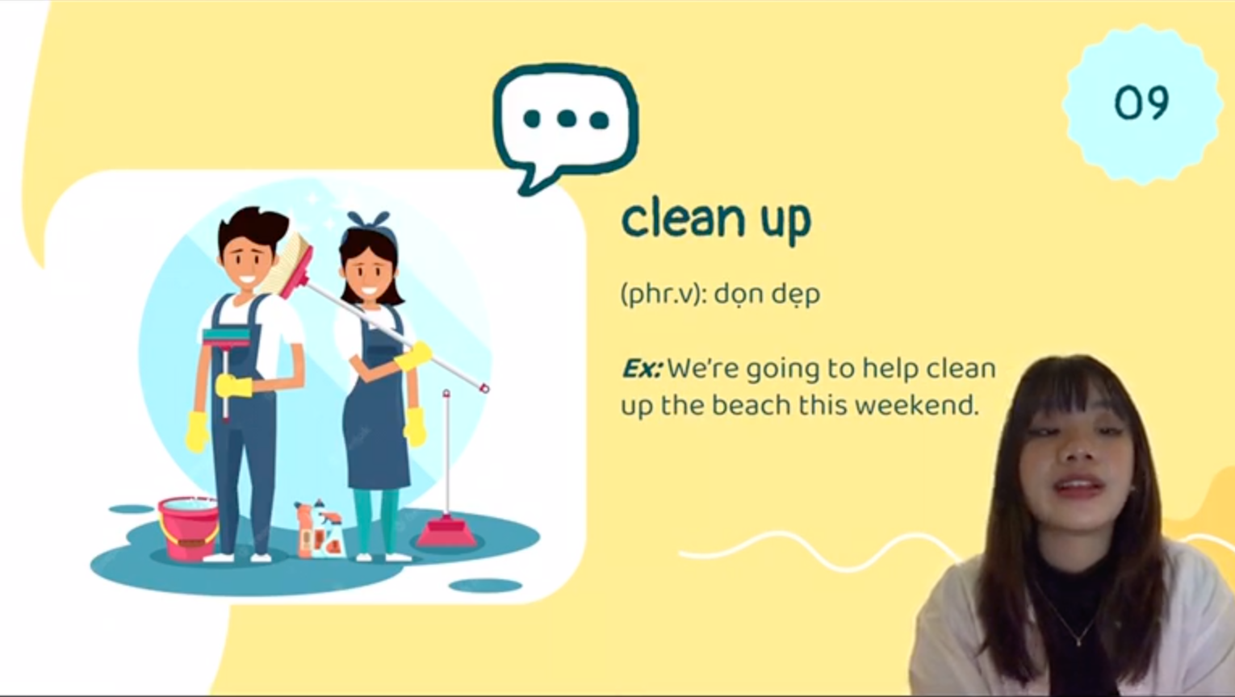 |  | Graphic info:
 |  | [2 people cleaning]
 |  | Navigation:
Animation
[1] graphic
[2] clean up
[3] (phr.v): dọn dẹp
[4] Ex: We’re going to help clean up the beach this weekend.
 |  | Reviewer comments:
Audio
Looking at the picture, can you guess what it is? This is what you do after a party to make it less messy, you “clean it up”. An example sentence is: “We’re going to help clean up the beach this weekend”

Project name: Unit 4: For a better community | Screen title: 10th word | Screen #: 10/12
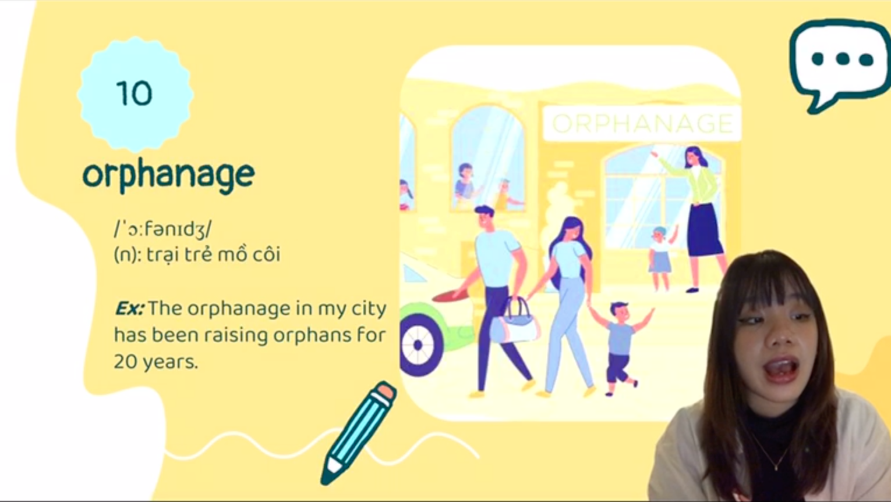 |  | Graphic info:
 |  | [People in an orphanage]
 |  | Navigation:
Animation
[1] graphic
[2] orphanage
[3] (n): trại trẻ mồ côi
[4] Ex: The orphanage in my city has been raising orphans for 20 years.
 |  | Reviewer comments:
Audio
So when a child doesn’t have his or her parents, they will live in an … “orphanage”. An example sentence is: “The orphanage in my city has been raising orphans for 20 years.”

Project name: Unit 4: For a better community | Screen title: 11th word | Screen #: 11/12
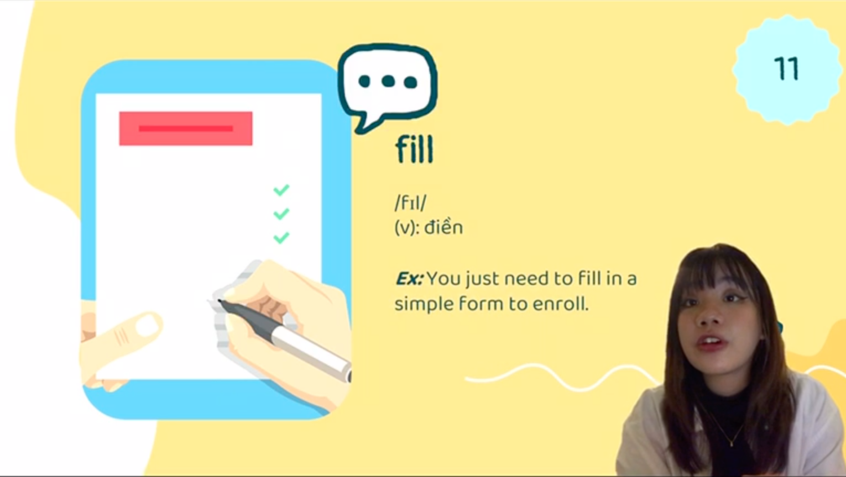 |  | Graphic info:
 |  | [A hand filling out a form]
 |  | Navigation:
Animation
[1] graphic
[2] fill
[3] (v) điền
[4] Ex: You just need to fill in a simple form to enroll.
 |  | Reviewer comments:
Audio
The eleventh word indicates when you see a gap, what we would do is “fill” it in. An example sentence is “You just need to fill in a simple form to enroll.”

Project name: Unit 4: For a better community | Screen title: 12th word | Screen #: 12/12
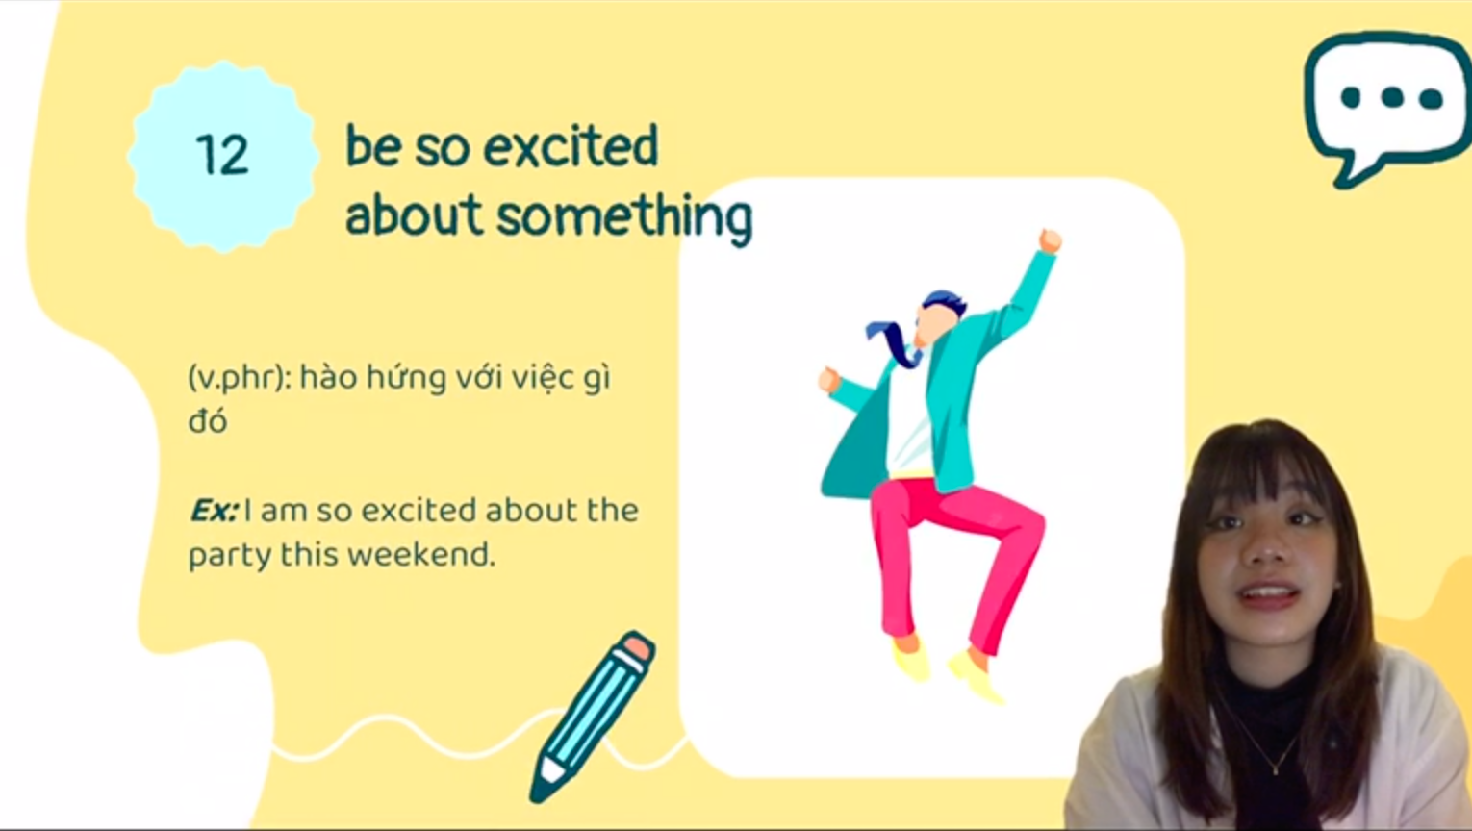 |  | Graphic info:
 |  | [Man jumping up from excitement]
 |  | Navigation:
Animation
[1] graphic
[2] be so excited about something
[2] (v.phr): hào hứng với việc gì đó
[3] Ex: I am so excited about the party this weekend.
 |  | Reviewer comments:
Audio
Okay, last word! So when we are really happy about something, we can say we “are so excited about something”. Like “I am so excited about the party this weekend.”
And that was it for today’s vocabulary. See you in the next lesson!

