Student’s Name:
Global Success
Unit 2
Humans and the Environment
~ Writing ~
- About improving the school’s environment –

Exercise 1:
Read this incomplete paragraph about some of the ways to improve the environment. Connect the numbered words/phrases with the correct functions, based on what they do in this paragraph.
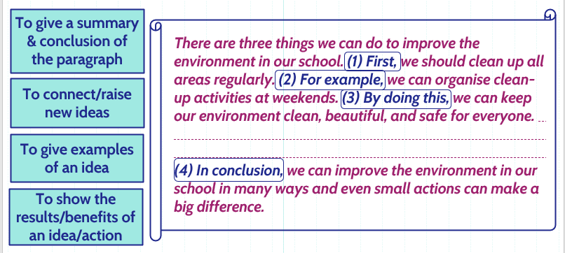

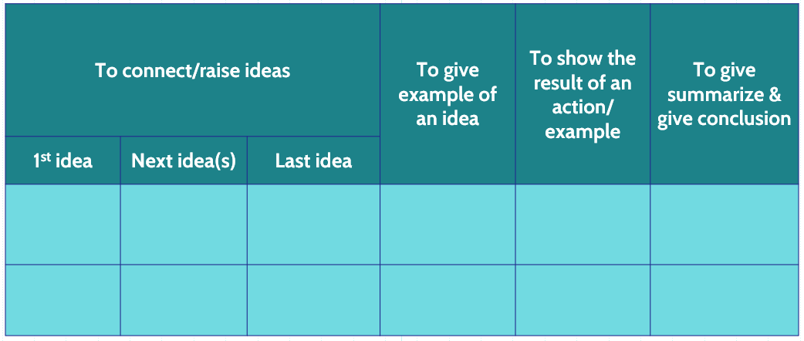
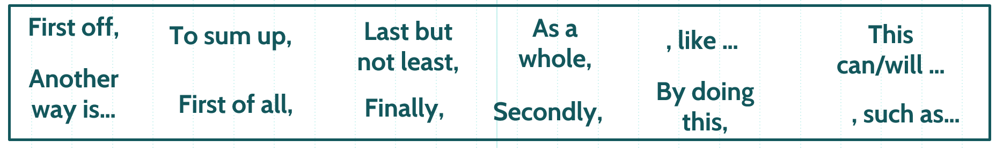

Exercise 2:
Read sample:
There are three things we can do to improve the environment in our school. First, we should clean up all areas regularly. For example, we can organise clean-up activities at weekends. By doing this, we can keep our environment clean, beautiful, and safe for everyone. Second, we ought to set up more rubbish bins. For instance, we can put more rubbish bins in the school gate, in front of each building, or in the playground. Thereby, we can make the waste collection easier. In addition, we should plant more trees. To give an example, we can encourage students to plant trees or flowers in our school because this reduces CO2 and makes the air clean. In conclusion, we can improve the environment in our school in many ways and even small actions can make a big difference.

