Grammar Unit 2: Will and Be going to

Screen title:
Audio: | On-screen text: | On-screen graphics: | Graphic notes & navigation: | Reviewer comments:
Hello, class! Today, we’ll discuss about the differences between “Will” and “Be going to”. | (Introduction)  “Will and Be going to” | 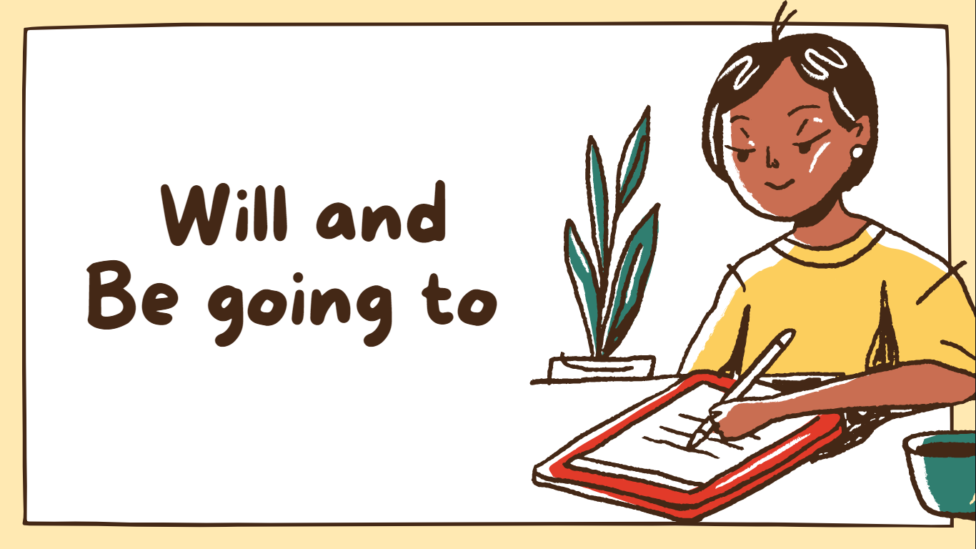 | Slide advances by user  NEXT= “Both are used to express the future actions. What is the difference?”
They are both used to express the future actions. So what is the difference? | Both are used to express the future actions. What is the difference? | 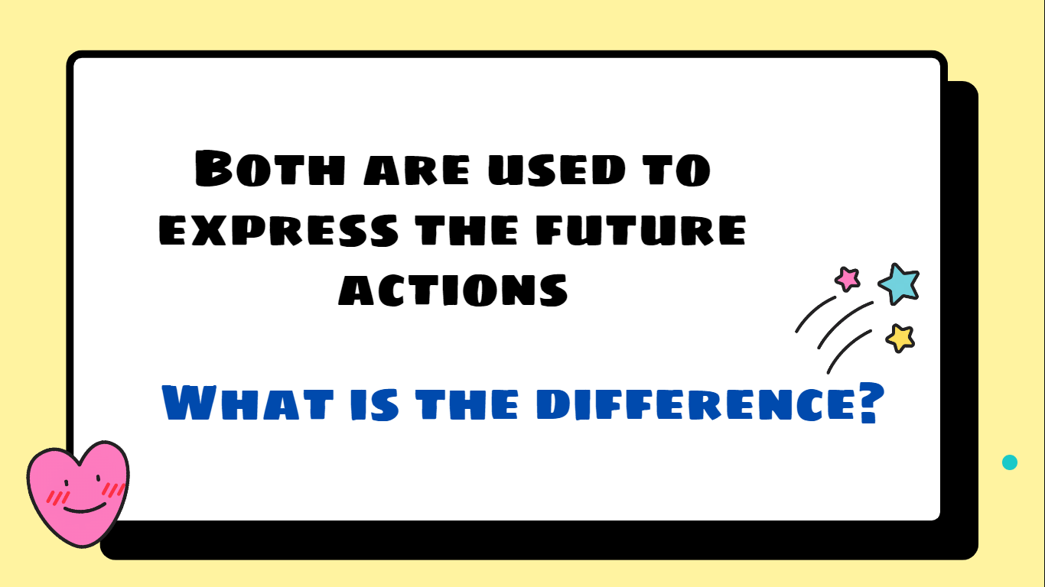 | Slide advances by user  NEXT= Be Going To
First, we talk about “Be going to” which is used to express personal intention or plans:  For example: We’ve made a plan before. We are going to join in the Summer Volunteer campaign. | Be going to  - Used to express personal intention or personal’s plans.  - E.g. We’ve made a plan before. We are going to join in the Summer Volunteer campaign. | 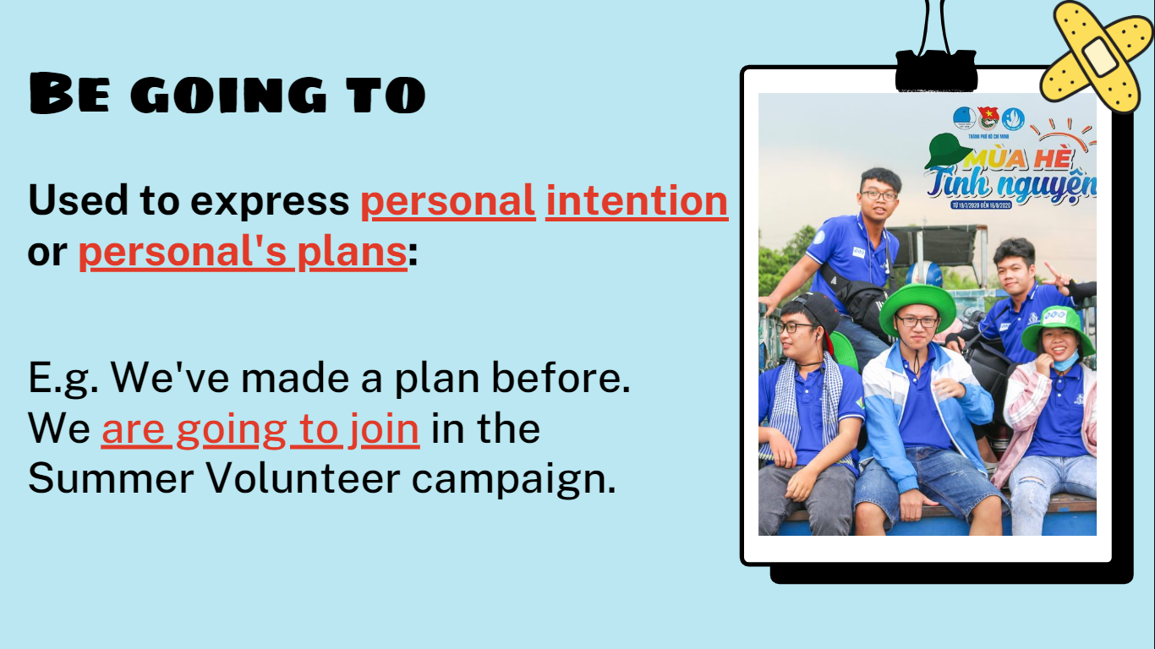 | Slide advances by user  NEXT= Will
How about “will”? It is used to express unplanned desire:  For example: I will join in the Summer Volunteer campaign. It means that I have just decide to participate this campaign immediately. There are no plans before | Will  - Used to express unplanned desire:  - E.g. I will join in the Summer Volunteer campaign.  I have just decided to join. There aren’t any plans before | 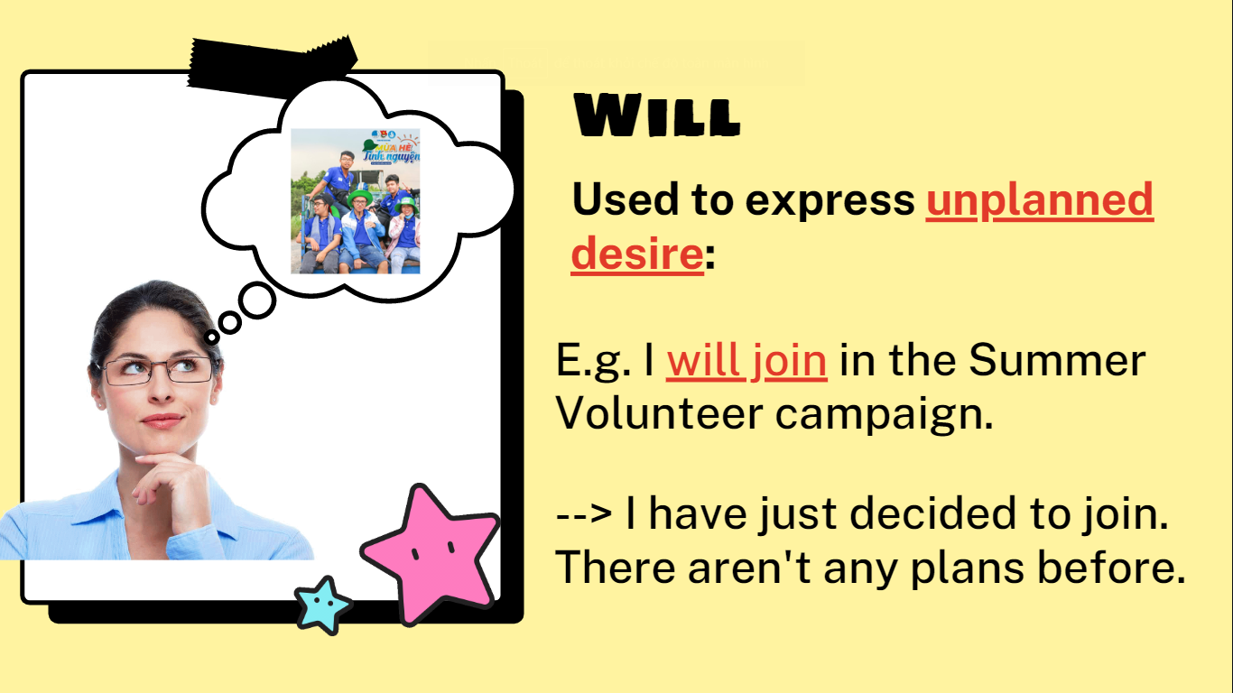 | Slide advances by user  NEXT= Prediction “Will”
Move to another use of these tenses that is prediction. “Will” is used to describe a prediction based on what you think or belive. For instance, I think France will be the winner. It is just because I am a fan of this football team | Prediction  Will  Based on what you think or believe  E.g. I think France will be the winner.  The prediction is made based on my liking. | 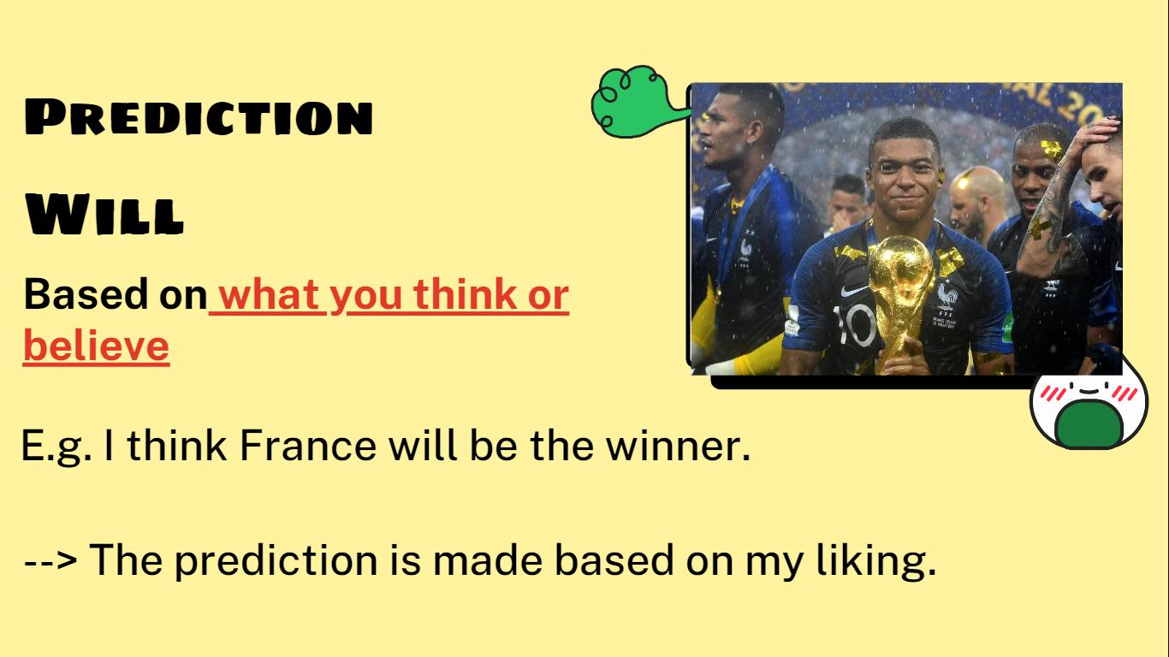 | Slide advances by user  NEXT= Prediction “Be going to”
On the contrary, prediction using “be going to” based on what you see or know. We can simply know the fact. For example. Look at the score board, France is going to be the winner. The evidence is on the score board, France has more goals for than other team. | Prediction  Be going to  Based on what we see or know  E.g. Look at the score board, France is going to be the winner.  The prediction is made based on real observation. | 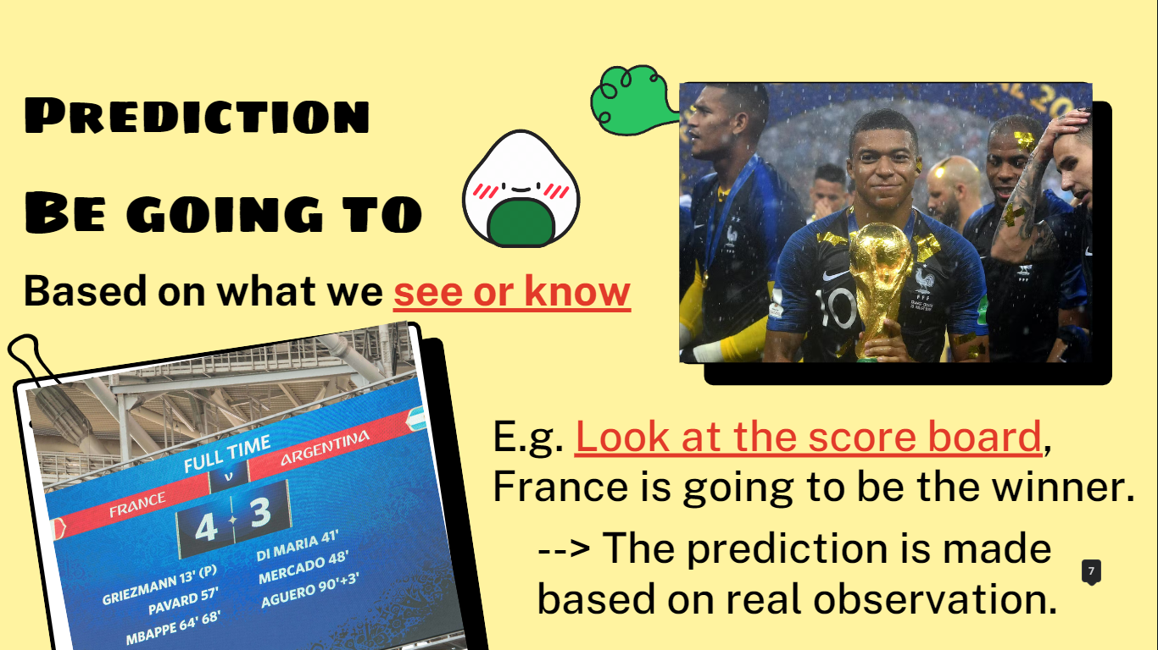 | Slide advances by user  NEXT= THANKS
In short, we have gone through differences between Will and Be going to. Thanks for your attention! | Thanks | 

