Project name: Vocabulary unit 2 | Screen title: Vocabulary unit 2 (intro) | Screen #: 1/7
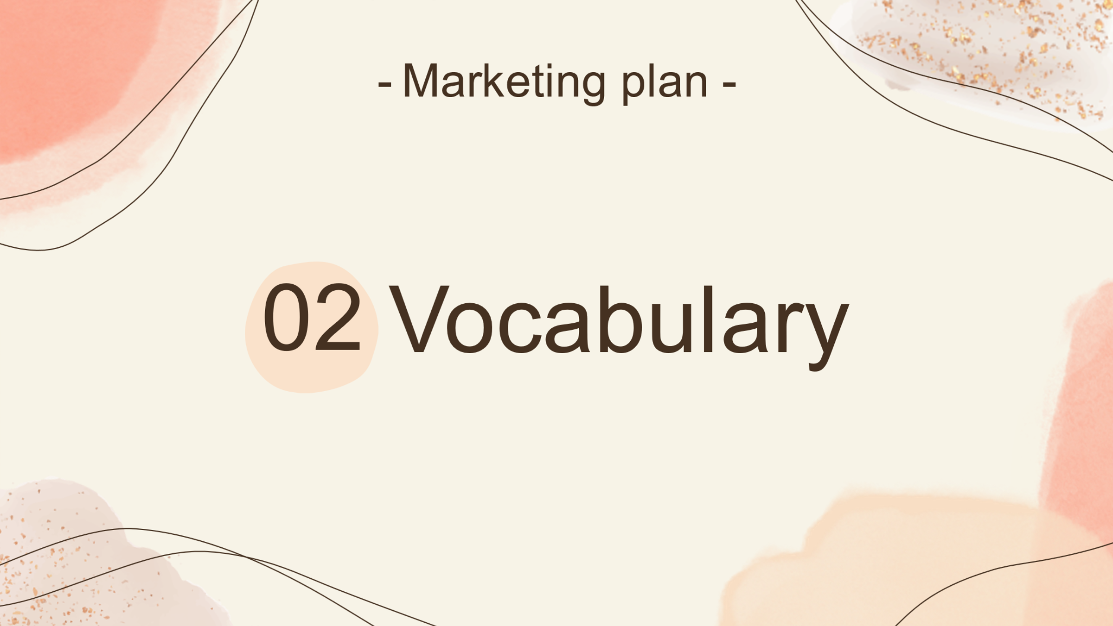 |  | Graphic info:
 |  | No imagination for texts and images
 |  | Navigation:
Slide advances by the presenter
NEXT = Breadwinner (2/7)

 |  | Reviewer comments:
Audio: We move on to the next part is Vocabulary

Project name: Vocabulary unit 2 | Screen title: Breadwinner | Screen #: 2/7
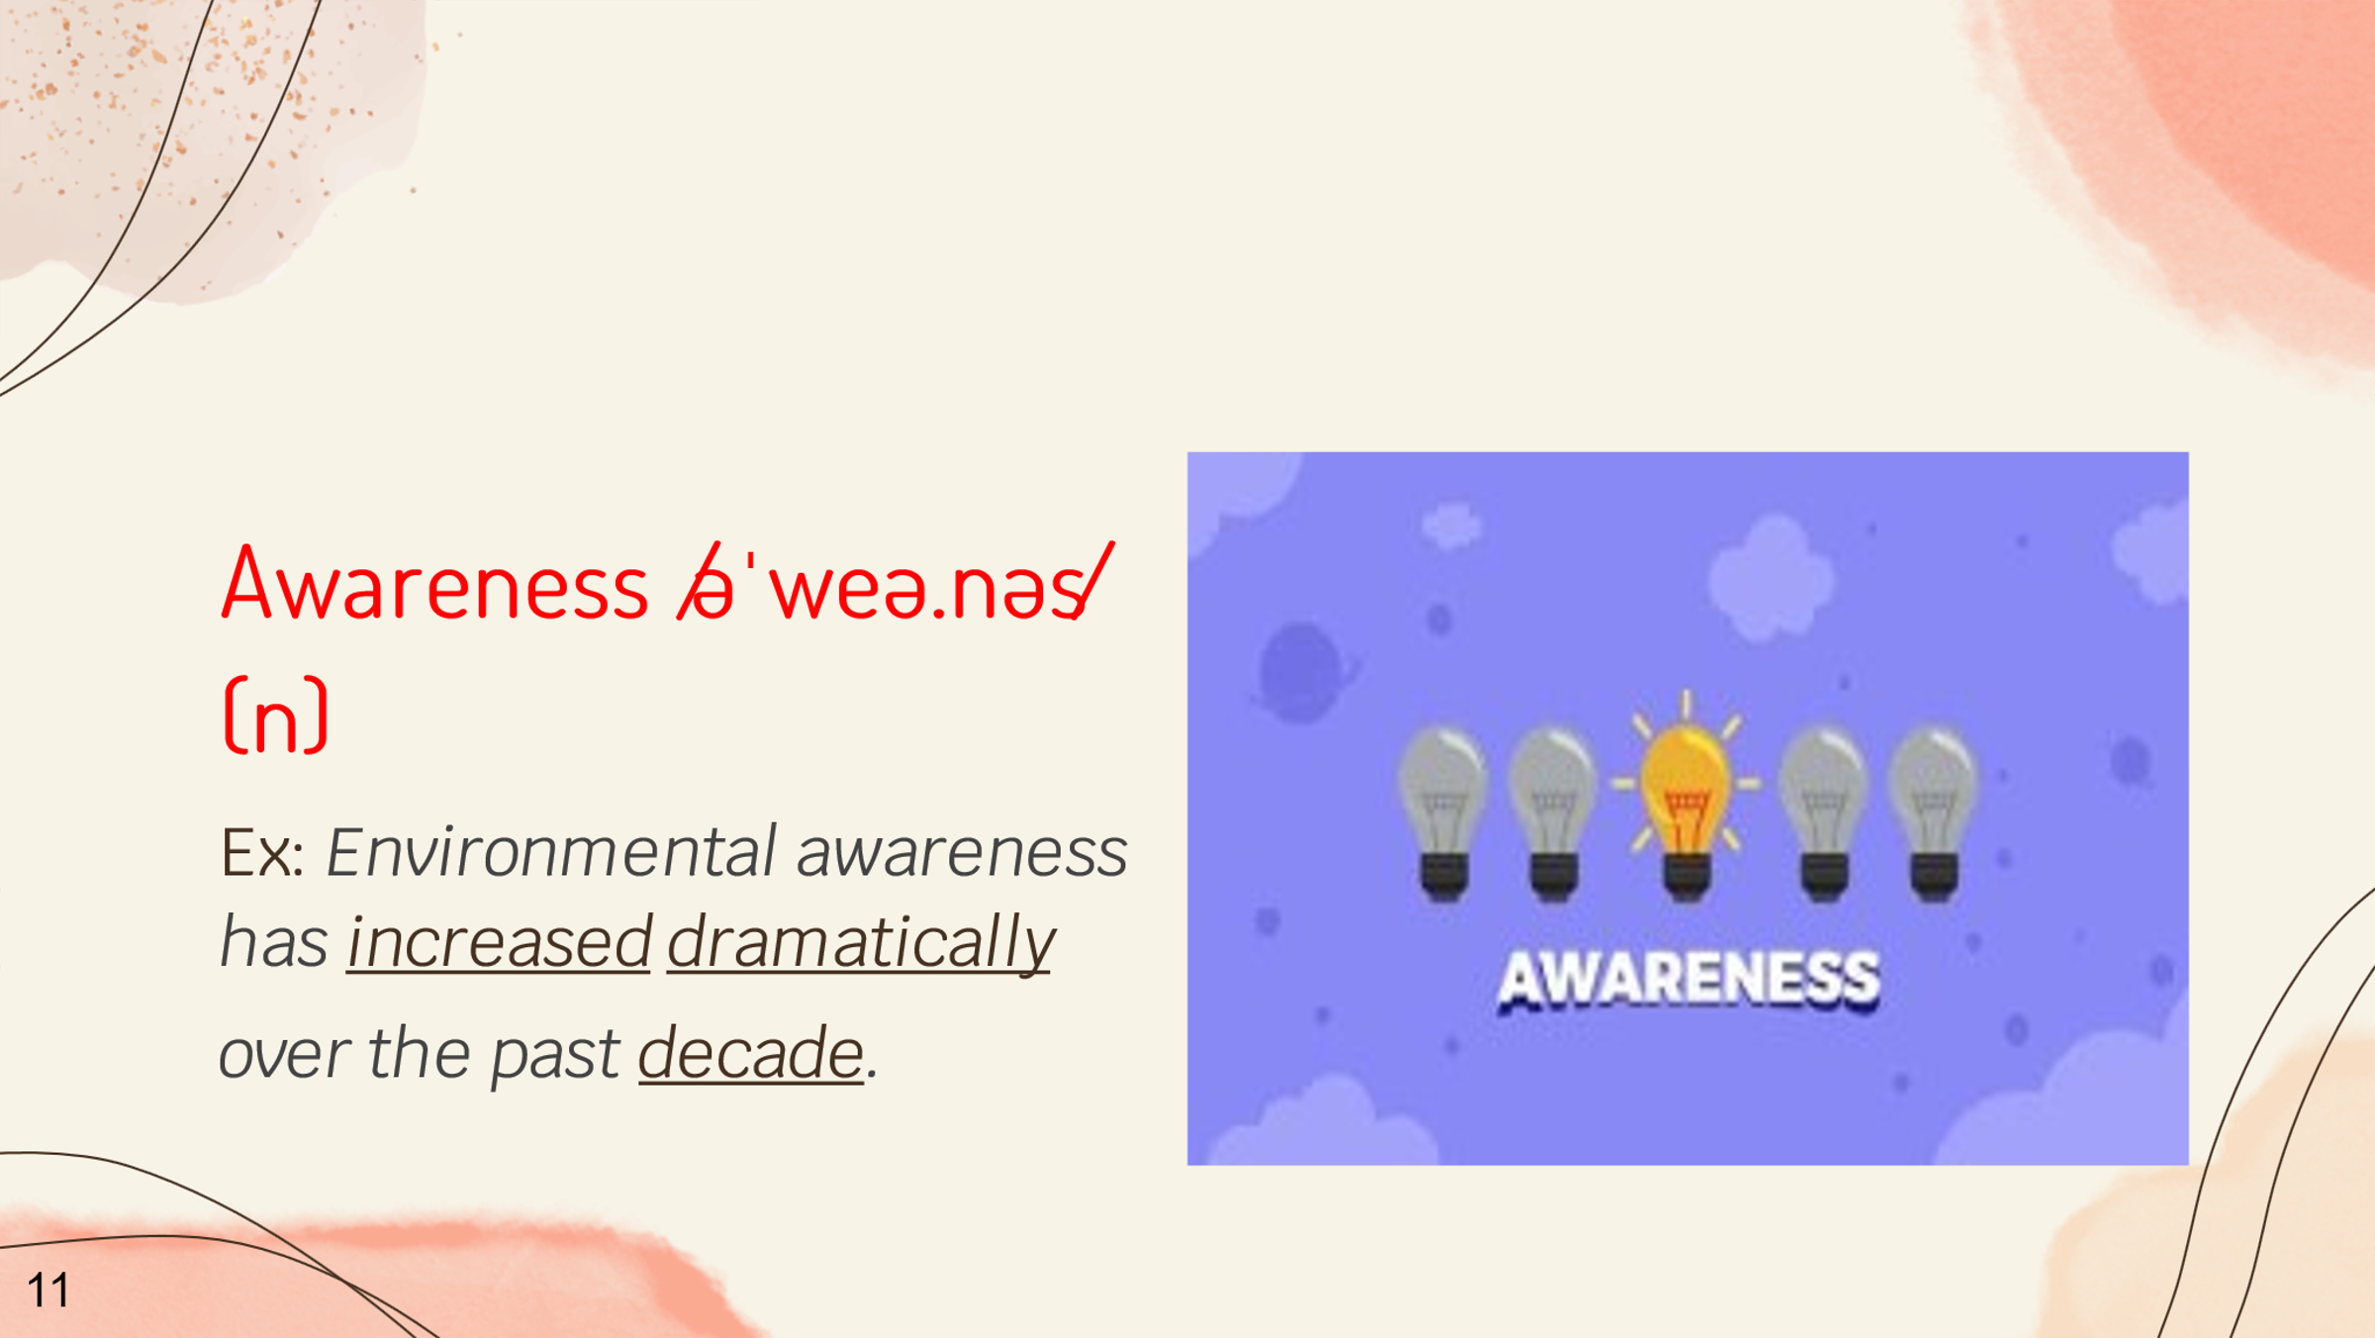 |  | Graphic info:
 |  | No imagination for texts and images
 |  | Navigation:
Slide advances by the presenter
NEXT = Chore (3/7)

 |  | Reviewer comments:
Audio: The first word is awareness. Awareness means knowledge that something exists, or understanding of a situation or subject at the present time based on information or experience. For example, Environmental awareness has increased dramatically over the past decade. Its Vietnamese meaning is sự nhận thức. “Awareness”

Project name: Vocabulary unit 2 | Screen title: Chore | Screen #: 3/7
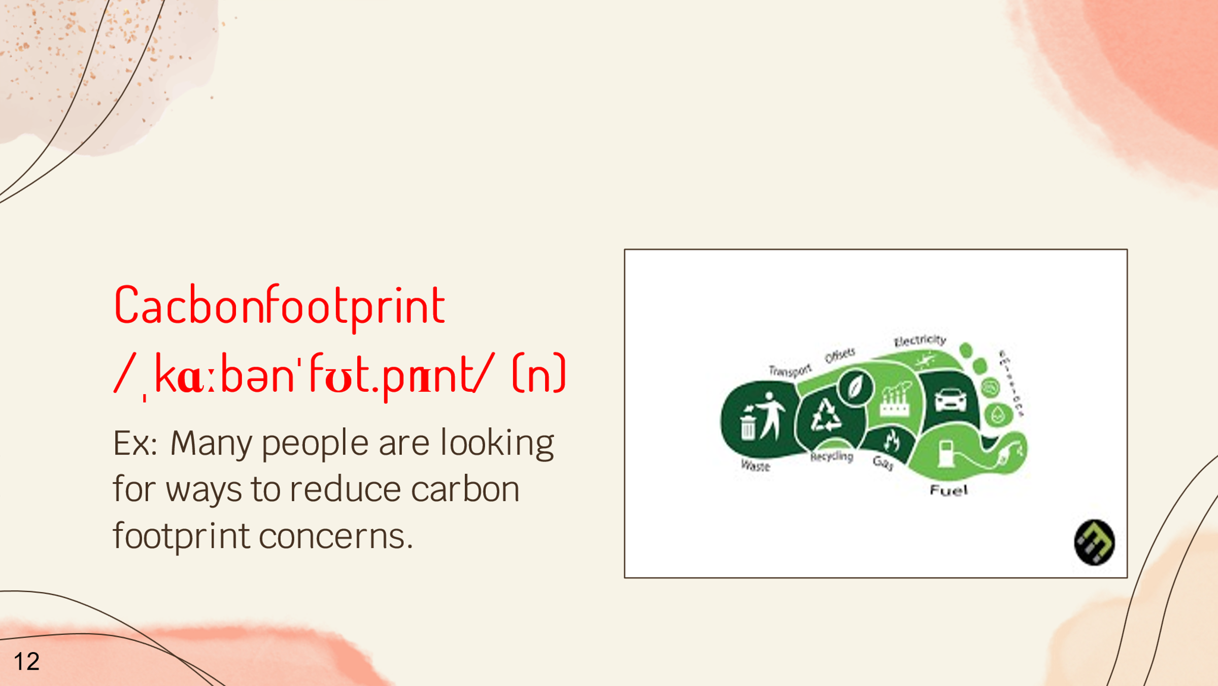 |  | Graphic info:
 |  | No imagination for texts and images
 |  | Navigation:
Slide advances by the presenter
NEXT = Groceries (4/7)

 |  | Reviewer comments:
Audio: The next one is Cacbon footprint. It means Someone's carbon footprint is a measurement of the amount of carbon dioxide that their activities produce. For example, Many people are looking for ways to reduce carbon footprint concerns. “Cacbon footprint”

Project name: Vocabulary unit 2 | Screen title: Groceries | Screen #: 4/7
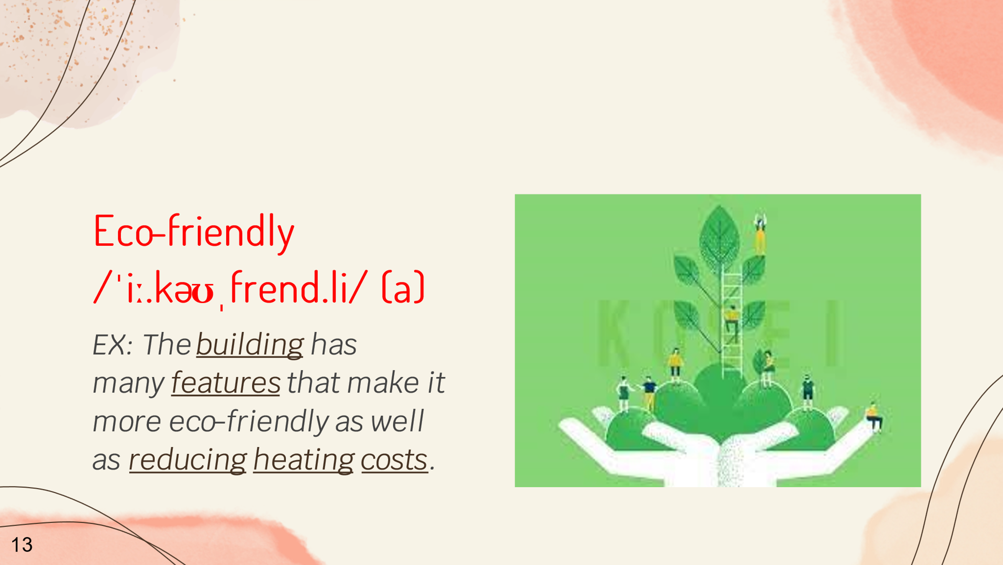 |  | Graphic info:
 |  | No imagination for texts and images
 |  | Navigation:
Slide advances by the presenter
NEXT = Homemaker (5/7)

 |  | Reviewer comments:
Audio: The next is Eco-friendly. Eco-friendly means For example, they don’t have enough money to buy their groceries. For example, The building has many features that make it more eco-friendly as well as reducing heating costs. “Eco-friendly”

Project name: Vocabulary unit 2 | Screen title: Homemaker | Screen #: 5/7
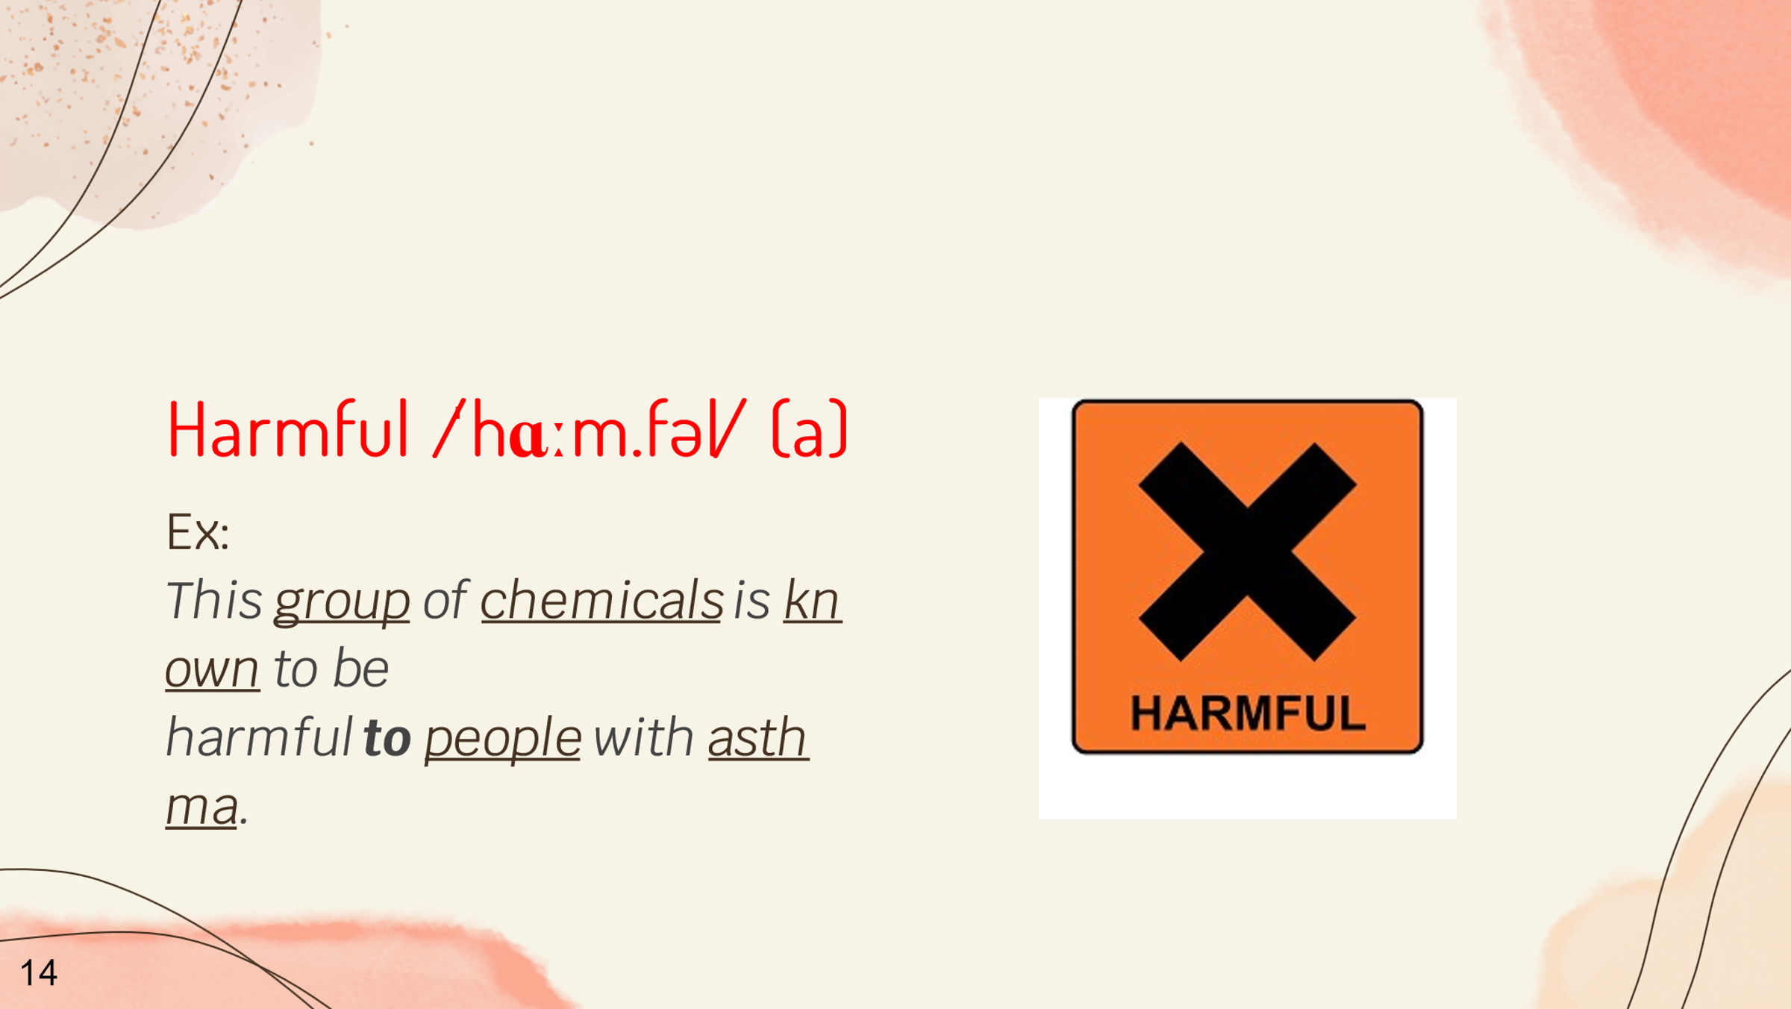 |  | Graphic info:
 |  | No imagination for texts and images
 |  | Navigation:
Slide advances by the presenter
NEXT = Heavy lifting (6/7)

 |  | Reviewer comments:
Audio: And then it’s harmful. Its mean is causing harm. For example, This group of chemicals is known to be harmful to people with asthma. “harmful”

Project name: Vocabulary unit 2 | Screen title: Heavy lifting | Screen #: 6/7
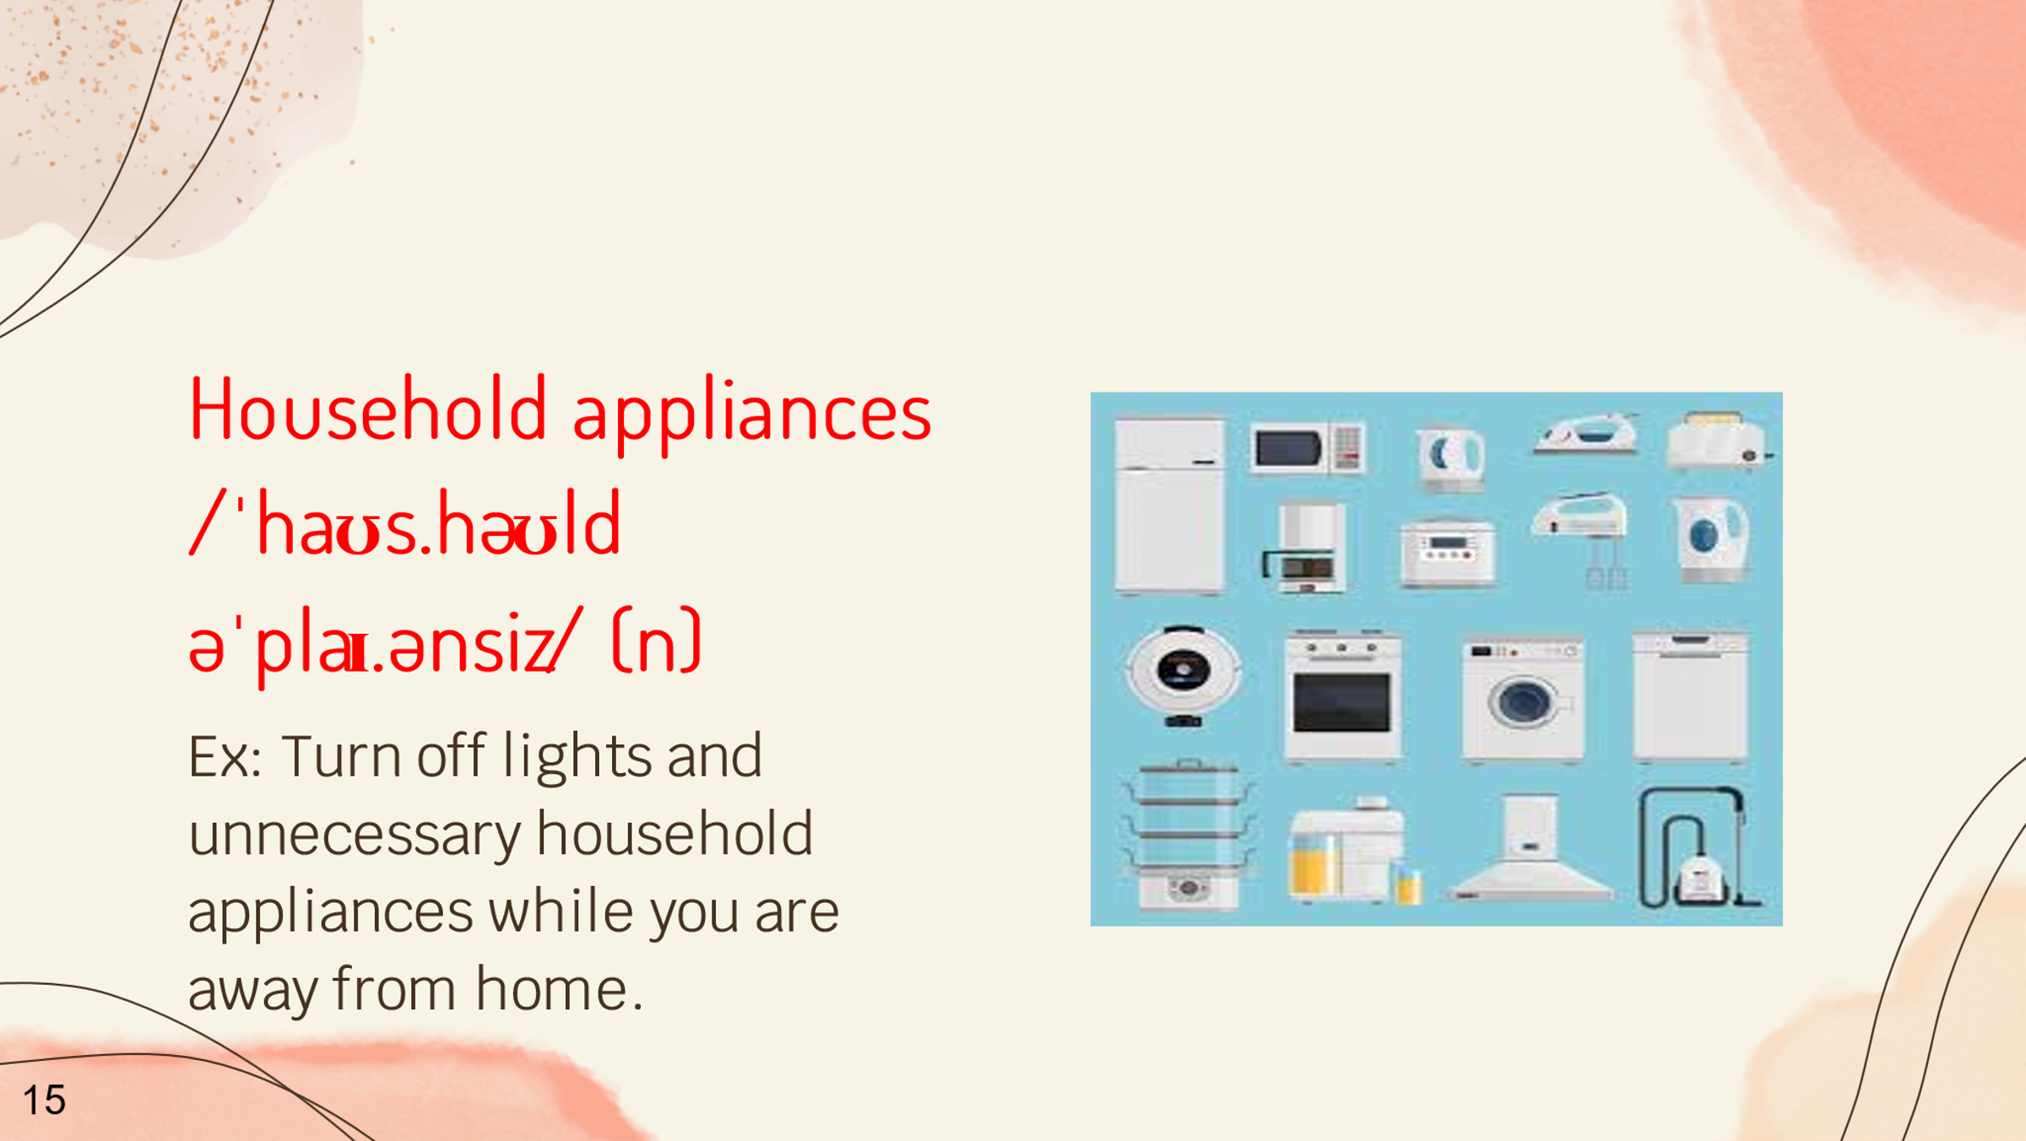 |  | Graphic info:
 |  | No imagination for texts and images
 |  | Navigation:
Slide advances by the presenter
NEXT = routine (7/7)

 |  | Reviewer comments:
Audio: Next, it is Household appliances. It means devices, such as fridges or TVs, used in people’s homes thiết bị gia dụng. For eaxmaple, Turn off lights and unnecessary household appliances while you are away from home. “Household appliances”

Project name: Vocabulary unit 2 | Screen title: Routine | Screen #: 7/7
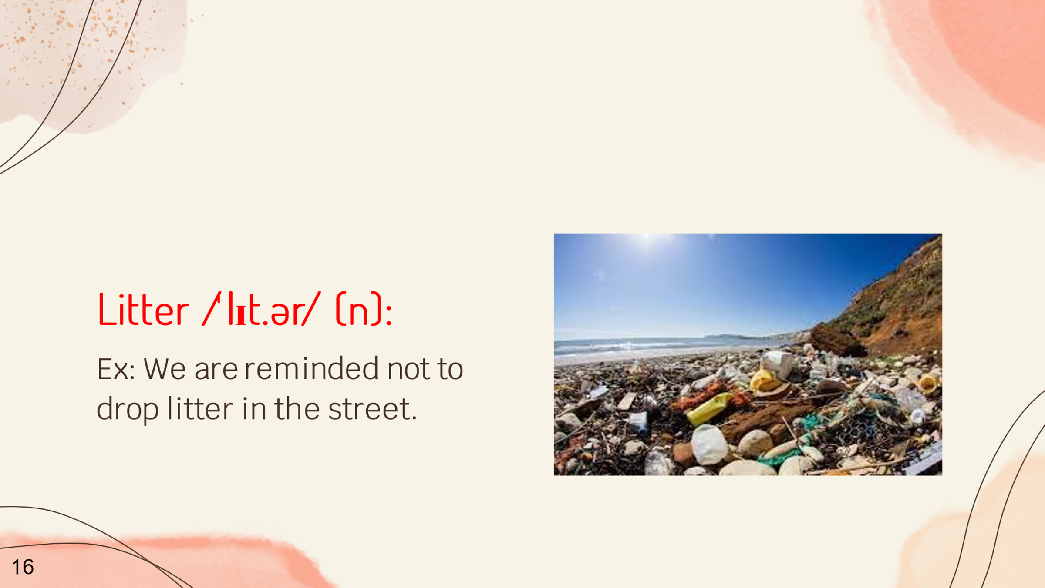 |  | Graphic info:
 |  | No imagination for texts and images
 |  | Navigation:
 |  | Reviewer comments:
Audio: The last word is litter. Litter means small pieces of rubbish that have been left lying on the ground in public places. For example, We are reminded not to drop litter in the stress. “Litter”

