Grammar Unit 8: Relative Clauses – Defining and Non-defining relative clauses

Screen title:
Audio: | On-screen text: | On-screen graphics: | Graphic notes & navigation: | Reviewer comments:
Hello, class! Today, we’ll learn about the “Relative Clauses” | (Introduction)  “Relative Clauses” | 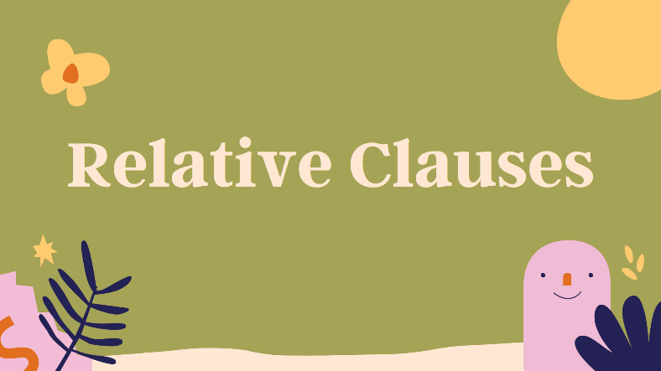 | Slide advances by user  NEXT= “Review”
Before going further, we will review what we have learn about relative clauses.  First, we use the relative clauses when we want to provide more information about people / things are mentioned.  Second, Relative Clauses often start with Relative Pronouns such as Who, Whom, Whose, Which. And Relative Adverbs such as When, Where and Why. | Review  Usage: to provide more information about people / things are mentioned.  Relative Clauses often start with  Relative Pronouns such as Who, Whom, Whose, Which.  Relative Adverbs such as When, Where, Why. | 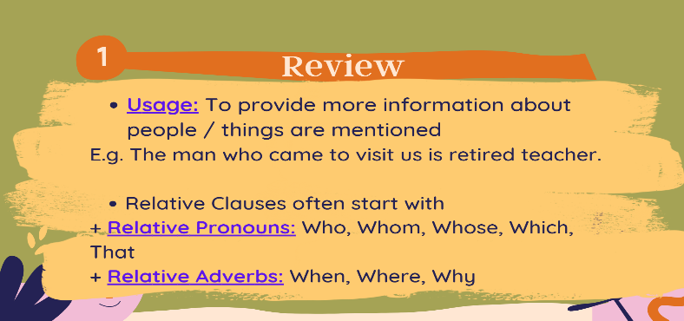 | Slide advances by user  NEXT= Relative Pronouns
For relative pronouns, we have  Who use in relative clauses are subject and object and use for people.  Whom is object and for people  And Whose is possessive and for both people and things. | - Relative Pronouns  WHO  FUNCTIONS IN RELATIVE CLAUSE: SUBJECT, OBJECT FOR PEOPLE.  WHOM  FUNCTIONS IN RELATIVE CLAUSE: OBJECT FOR PEOPLE.  WHOSE  FUNCTIONS IN RELATIVE CLAUSE: POSSESSIVE FOR PEOPLE OR THINGS. | 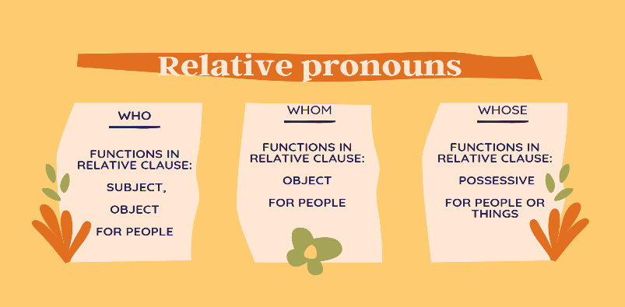 | Slide advances by user  NEXT= Relative pronouns
Next, we have  Which use for subject and object replace things.  And the last one, That for object. We use that for people or things | Relative pronouns  WHICH  FUNCTIONS IN RELATIVE CLAUSE: SUBJECT, OBJECT FOR THINGS.  THAT  FUNCTIONS IN RELATIVE CLAUSE: OBJECT FOR PEOPLE OR THINGS. | 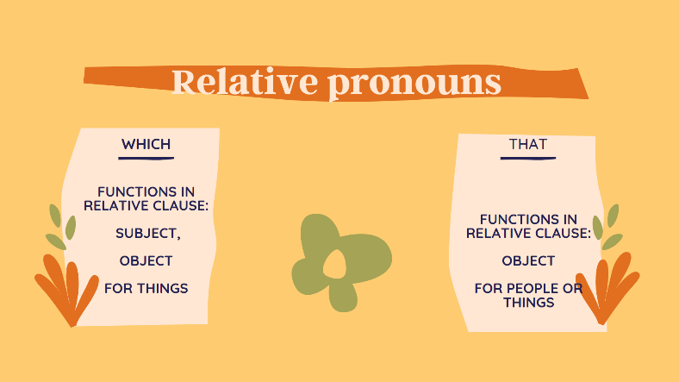 | Slide advances by user  NEXT= Defining and Non-defining relative clauses
Now, we come to the defining and non-defining relative clauses. | Defining and Non-defining relative clauses | 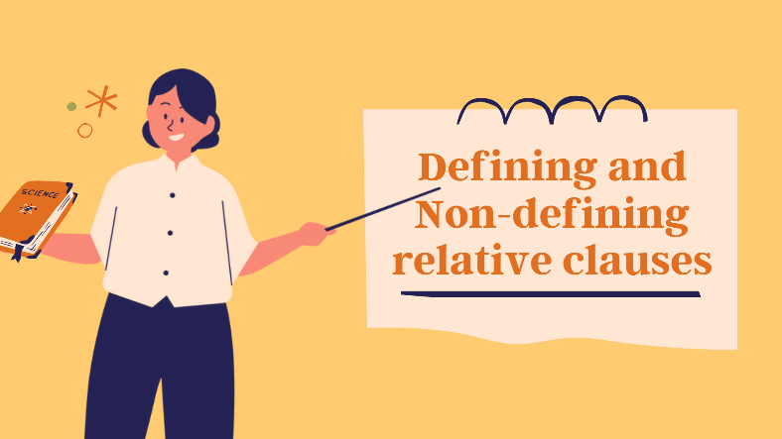 | Slide advances by user  NEXT=Defining and Non-defining relative clauses
These are 2 examples of Defining and Non-defining relative clause. | Defining and Non-defining relative clauses  - The boy that she’s playing with is my brother.  - Mr. John, who is my English teacher, has won the lottery. | 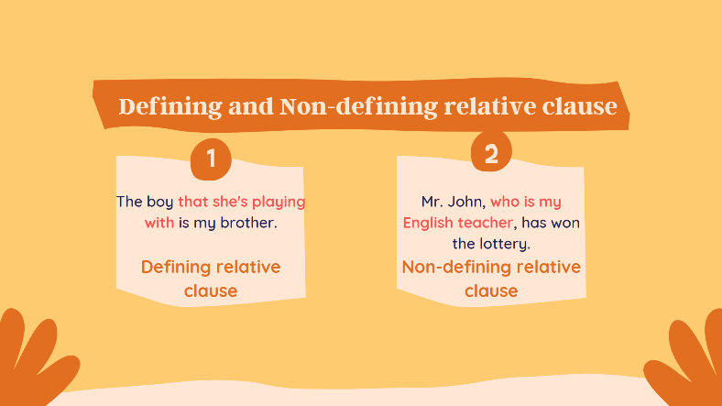 | Slide advances by user  NEXT=Defining and Non-defining relative clauses
When we look at the first example, a noun “The boy” is a non-defining noun because listeners cannot understand who boy is? On the other hand, we can understand a noun John or Mr. John in the situation which is leading the Usage above. And one more thing is we can use “That” in Defining clause while non defining is not and it also separate by a comma as you can see on the slide. | Defining and Non-defining relative clauses.  Defining  Usage: Add the meaning for a non-defining noun.  Characteristic: Can use “That” in the sentence.  E.g. The boy that she’s playing with is my brother.  Non-defining  Usage: Add the meaning for defining noun.  Characteristic: Can not use “That” in the sentence.  E.g. Mr. John, who is my English teacher, has won the lottery. | 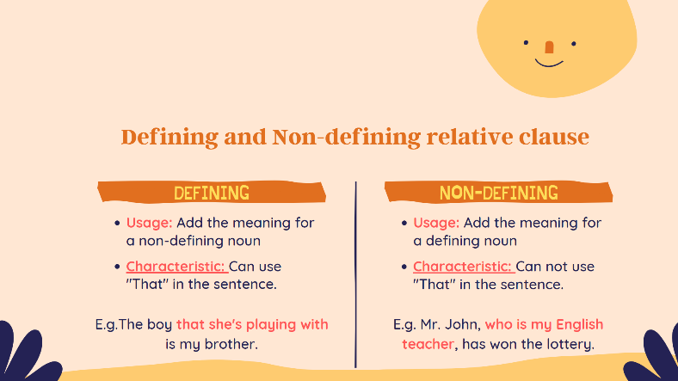 | Slide advances by user  NEXT=Thank you for attending
In short, we have gone through the usage and the characteristic of defining and non-defining relative clauses. Remember to do the quiz on LMS. Goodbye and see you. | Thank you for Attending  Remember to do the quiz on LMS. | 

